Boxed Set

By Andrea Landaker
illustrations by Lisa Horner

“Boxed Set” by Andrea Landaker (c) 2012 is licensed under a Creative Commons Attribution-NonCommercial-ShareAlike 3.0 License, http://creativecommons.org/licenses/by-nc-sa/3.0/

Introduction
“Boxed Set” is a parlor LARP for 10 people that takes about 1-2 hours. It has some supernatural and steampunk and historical fiction elements and takes place in 1901. Each character has goals – information they wish to gain, or hide, or events they hope to bring about, or objects they wish to acquire. But as each character tries to attain their goals, they will uncover a weave of connections that hides the true story behind past, present, and future.
Table of Contents
Boxed Set 1
Introduction 2
Player's Introduction 5
Game Master Guide 8
Act 1 10
Captain Thomas Sibbald 11
Mitsuri Sagawa 14
Franco Romano 17
Lucia Romano-Moreau 20
Doctor Mathilda von Hessel 24
Jake Jackson 28
Professor Alexander Ignatius 32
Palla Puma 35
Act 2 39
Captain Thomas Sibbald 40
Mitsuri Sagawa 41
Franco Romano 42
Lucia Romano-Moreau 43
Doctor Mathilda von Hessel 44
Jake Jackson 45
Professor Alexander Ignatius 46
Palla Puma 47
Act 3 48
Captain Thomas Sibbald 49
Mitsuri Sagawa 50
Franco Romano 51
Lucia Romano-Moreau 52
Doctor Mathilda von Hessel 53
Jake Jackson 54
Professor Alexander Ignatius 55
Palla Puma 56
Conclusion 57
Captain Thomas Sibbald 58
Mitsuri Sagawa 59
Franco Romano 60
Lucia Romano-Moreau 61
Doctor Mathilda von Hessel 62
Jake Jackson 63
Professor Alexander Ignatius 64
Palla Puma 65
Additional Characters 66
Yaku Puma 67
Hugo Yager 68
Yi Fang 70
Pirate 72
Vampire Pirate 73
Atlantean 74
Narrator 75

Player's Introduction

As the century turns, the world is changing. Clipper ships can cross the oceans much faster than previous ships, bringing trade and news faster than ever. New inventions such as the telegraph, light bulb, and phonograph diminish the influence of time and distance. The steam engine has made trains and factories more and more prevalent, and the divide between the rich businessmen and the poor factory workers is great. Waves of immigrants coming to the United States have brought their own ideas and customs.
Our story starts in the year 1901 on Captain Sibbald's clipper ship, the "Salty Swan". Two weeks ago, you all boarded the ship at San Francisco, bound for Shanghai, China and then Shimoda, Japan. The captain expects to reach Shanghai in about another week. So far, the voyage has been fairly uneventful – there have been days of seasickness, days of no wind, and days of boredom. But last night there was a terrible storm, and all the passengers were told to stay in their rooms. Today the seas are calm once more. The captain has invited all of you to dine in his quarters, as you often do, and you are expecting an enjoyable evening with the other passengers aboard the Salty Swan.

Characters

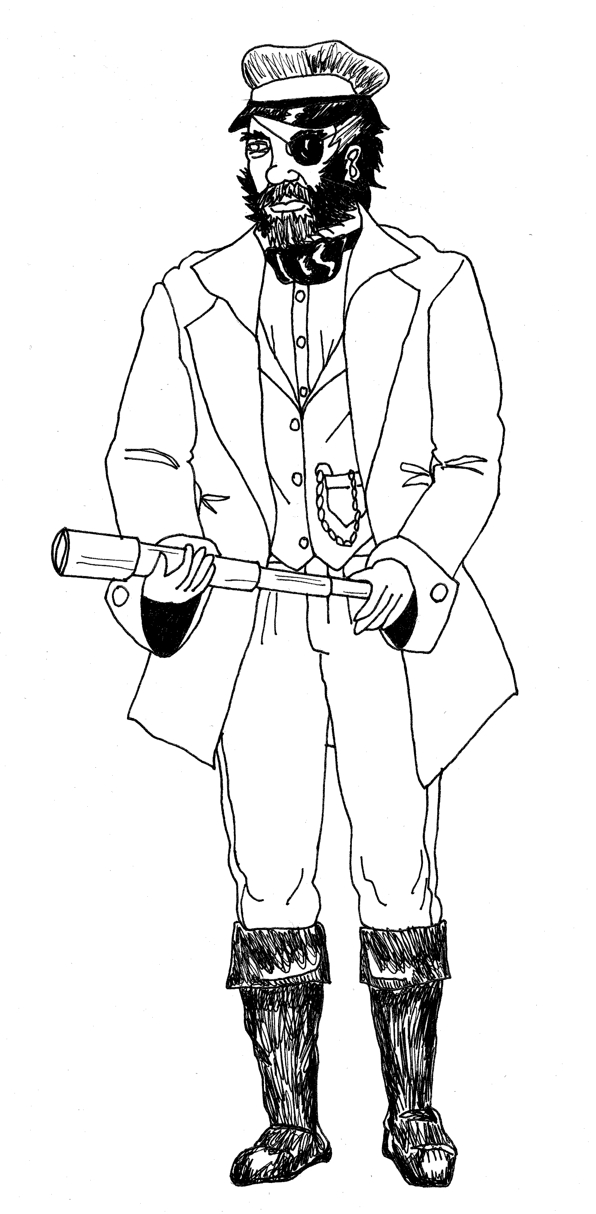
Captain Thomas Sibbald - The gruff but respected captain of the Salty Swan, he is bringing equipment and supplies to trade in the Far East.

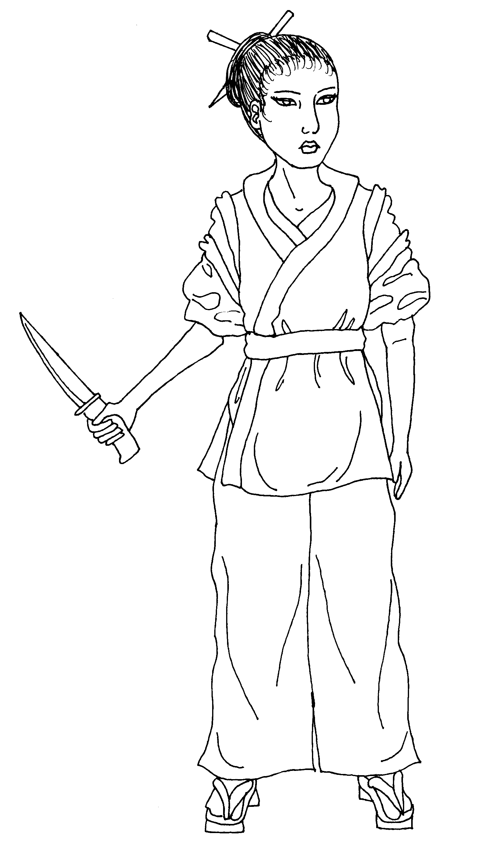
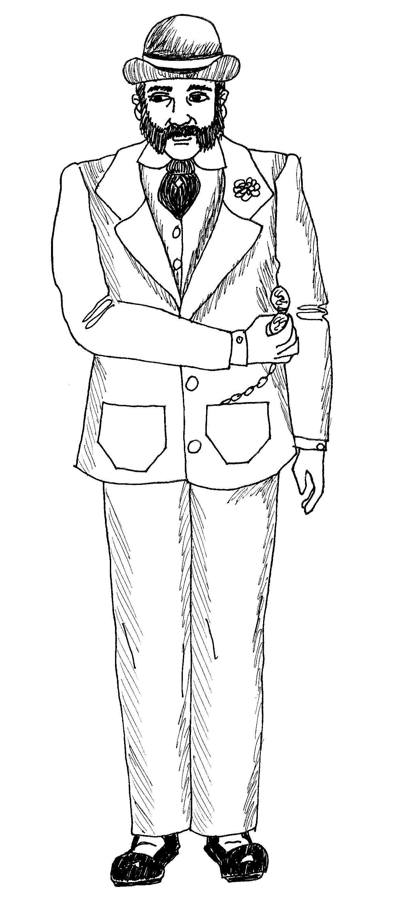
Mitsuri Sagawa – A nimble Japanese woman, she is the cook of the Salty Swan, and has the trust of the captain. She has also been translating and facilitating trade.

Franco Romano - An impeccable, reserved Italian gentleman going to Shanghai for business. He inherited his family estate in San Francisco when his parents died.

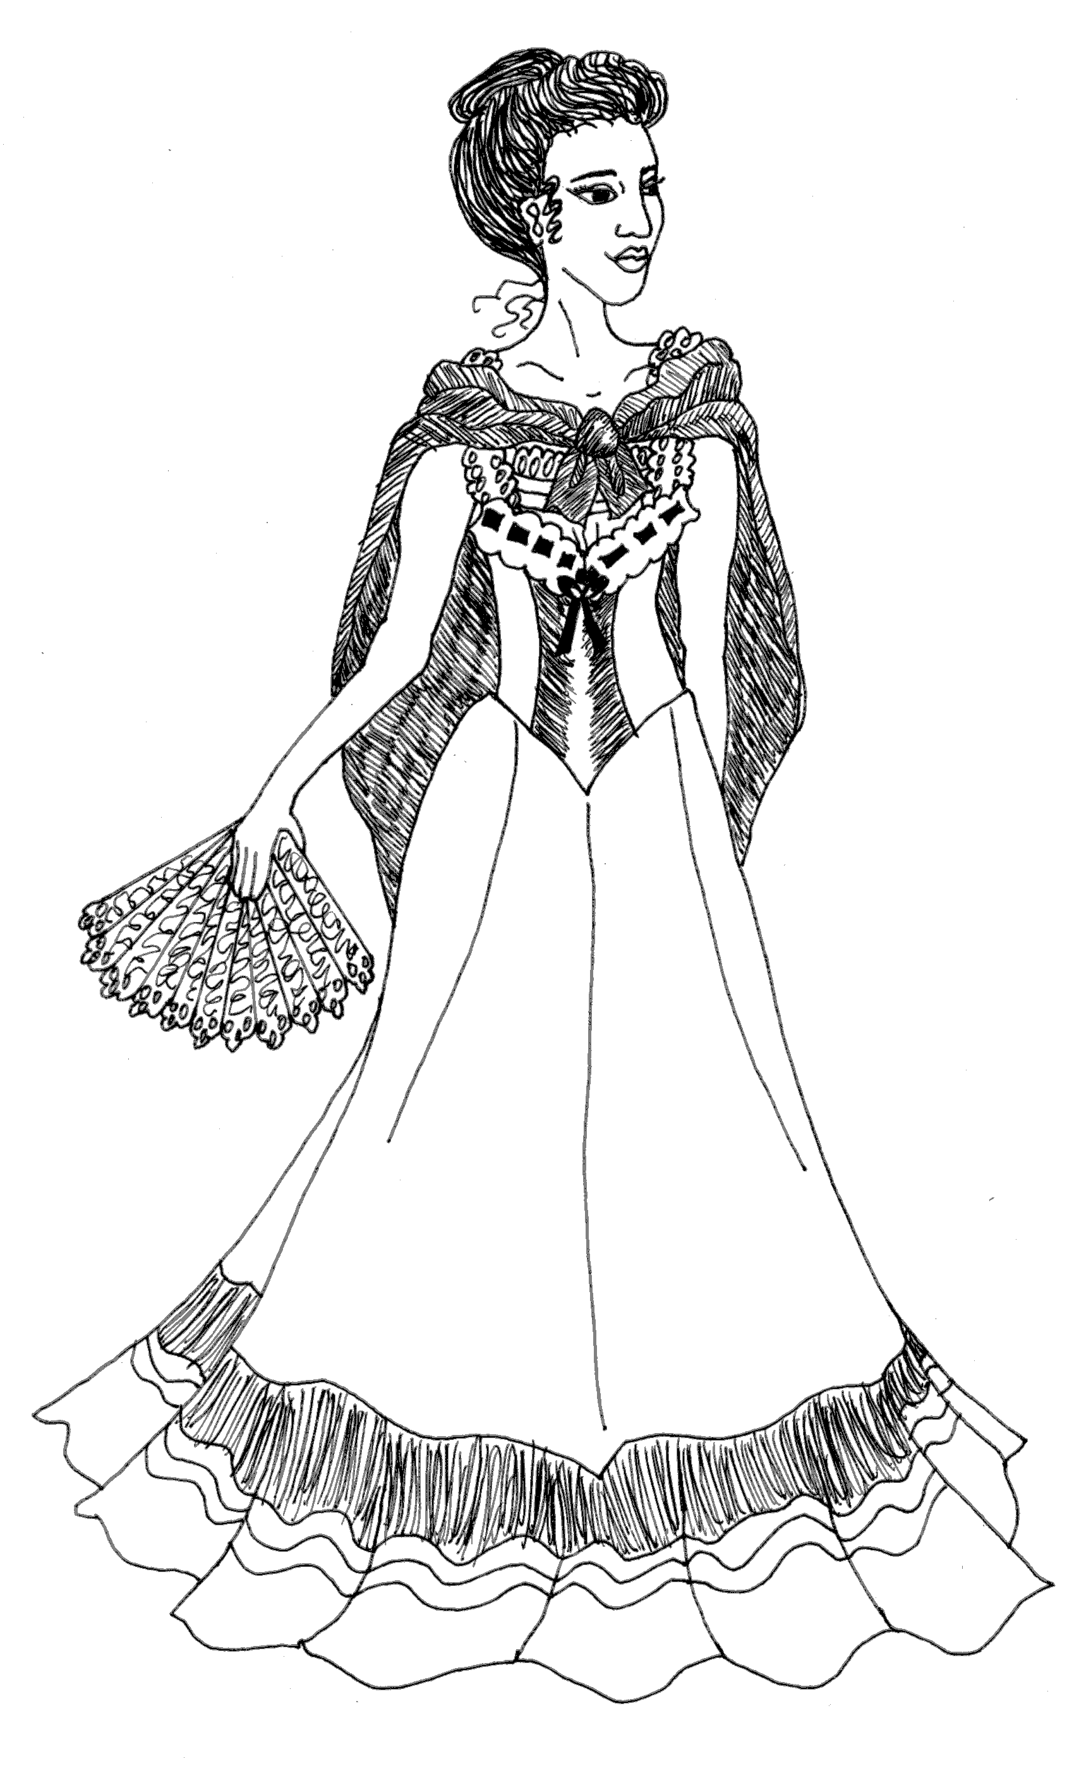
Lucia Romano-Moreau – Franco's older sister, she is joining him on his trip to Shanghai. Recently a widow, she has been ill for much of the trip so far.

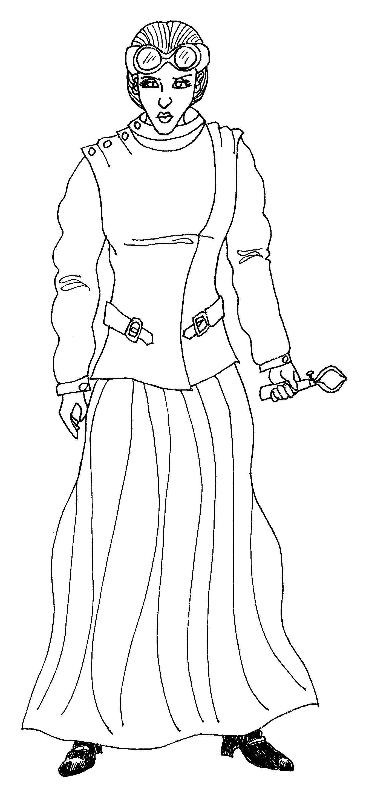
Doctor Mathilda von Hessel - Lucia's friend is traveling with her.. Mathilda is a scientist and inventor who is currently studying various applications of electricity.

Jake Jackson - This impulsive cowboy is Mathilda's research assistant. He's seen everything west of the Mississippi to the great blue yonder.

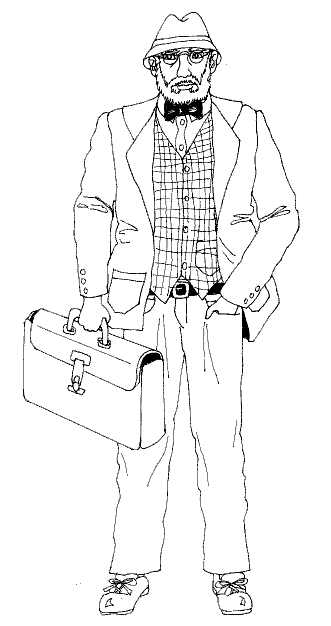
Professor Alexander Ignatius - An archaeologist from Harvard University, he, too, is traveling to China for research.

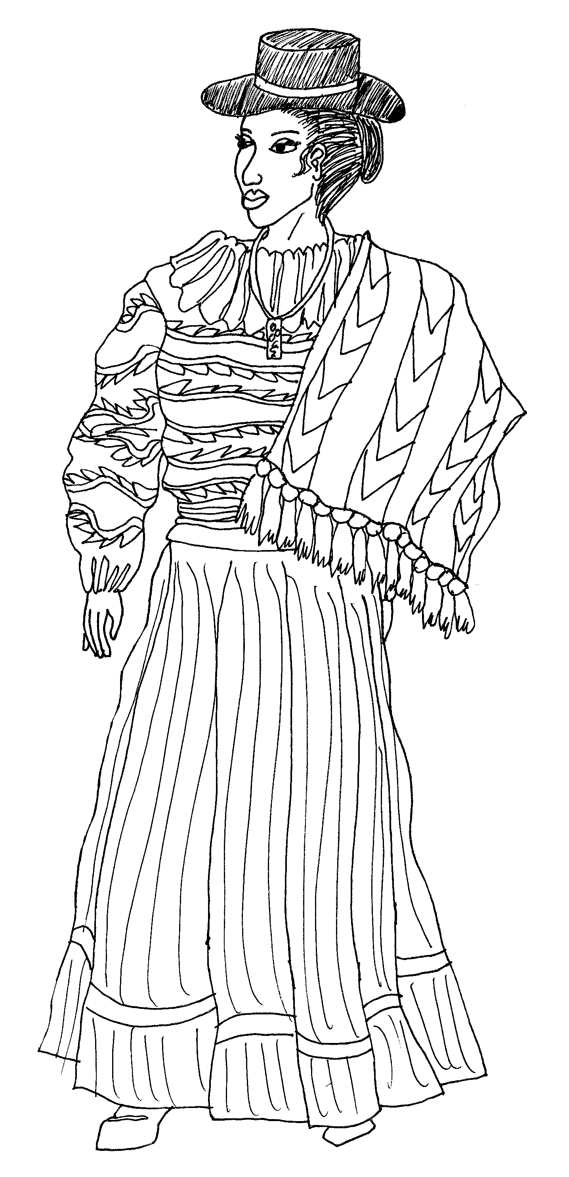
Palla Puma - This mysterious woman follows Franco around like a shadow. She looks like she is a native of the Americas, and has some skill with herbs.

Costumes
See http://en.wikipedia.org/wiki/1900s_in_fashion for an overview of period fashions.

Captain Thomas Sibbald - Trousers, jacket, and a seafaring cap. A belt with sword and/or gun would be appropriate.
Mitsuri Sagawa - A kimono-style shirt with wide trousers, or plain sailor's clothes, or Japanese work clothes (samue).
Franco Romano - A suit, preferably with vest and jacket, top hat or bowler hat optional. A flower in your lapel or a pocket watch would be appropriate accessories.
Lucia Romano-Moreau - A light, tea gown-style dress, or blouse and long skirt. Black or dark colors are appropriate, as you are still mourning your husband. A parasol or light wrap or large hat adds a nice touch.
Mathilda von Hessel - A white blouse with a long, heavy skirt. A white lab coat and glasses or goggles show off your genius well.
Jake Jackson - White shirt, trousers or chaps or jeans, and a cowboy hat. Suspenders and bandanna would also look nice.
Professor Alexander Ignatius - White shirt and casual trousers, with a fedora-style hat, jacket, and some sort of briefcase.
Palla and Yaku Puma - Ruffled blouse, with a colorful long skirt. Some sort of Andean poncho would help keep you warm at sea, and a necklace or amulet would look nice.

Game Master Guide
The rest of this document contains spoilers. If you will be participating as a player, you will have the most fun if you do not read further.

Preparing the Setting
This is where you have the most freedom. The setting can be as simple or as elaborate as you like. The mystery takes place on board a ship, in the captain's quarters. You can decorate with a nautical theme (nets, seashells, boats, etc.), or an Asian theme (lanterns, a screen, etc.), or just have a table and some chairs. The interactions work best if all the main characters can sit at a large table together, but any place where they can mingle and talk together would work fine.
You can serve a meal, or just have snacks or drinks. Mitsuri can help with serving food, clearing dishes, etc. If you do serve a meal, you may want to think about some sort of seafood dish, such as paella, jambalaya, tempura, grilled shrimp or fish, sushi, or whatever else you like.
Music adds a great deal to the atmosphere. Romantic classical music, ragtime, Irish folk music, opera, or other music from the late 19th century would work. Composers of the day include Debussy, Mahler, Grieg, Sousa, Tchaikovsky, Gilbert & Sullivan, and Joplin. While there were no radios or record players in 1900, phonographs were in use. If you would like a recording of ambient ship noise to use as sound effects, e-mail the author, andrea@icecavern.net.
You will also need to print out an introduction and character list for each player, as well as everyone's character sheets for each act and evidence.
Integral to the plot is a box, about the size of a cereal box. A cardboard box is fine; you can print out and glue on the Box Labels provided if you wish. This box should be somewhere out of sight but accessible to you during the party.
Having name tags for each character is very helpful to the players. Costumes are encouraged, but not required.
As GM, it would be best to read through everyone's sheets for each act several times so that you know what to expect and when each act is finished.

Timeline
There are three acts to this interactive drama, and a conclusion. It will probably take around 1-2 hours. Don't rush your players, but if it seems like everyone has run out of things to talk about, you can end the act. Once you're ready to start the next act, have the guests read the next section, and then start discussion once everyone is finished reading.

Act 1 – hand out Act 1 sheets, read the Narrator's “Introduction” piece. The characters will mostly be chatting, asking each other questions, and eventually it will be revealed that the Box is missing. Jake may also talk about his bank-robbing incident. When you wish to end the act, give Hugo his “End of Act 1” sheet. After he has spoken and left the room, give everyone their “Act 2” sheets.
Act 2 – You can set a timer for 10 minutes, or just let the party discuss for a reasonable amount of time. Someone should reveal that Hugo is a vampire, and they should also know that Mitsuri stole the box from the captain. At the end of the discussion, have Hugo reenter. As the GM and narrator, you can narrate any action that happens while the players act it out. If you feel that the players did not come up with a good plan, or you think it would make the game better, you could have some players get injured. Mitsuri and Jake are less integral to Act 3 and would be good choices for this. Once Hugo is taken care of, give everyone their “Act 3” sheets.
Act 3 – Give the Professor “A Letter found in Lucia's Handbag.” Lucia's true nature will be revealed, as well as Mathilda's role in the creation of vampires. They should learn what the Box actually is, and probably Franco's secret identity will be revealed as well. Once everyone has had a chance to decide what to do about Lucia and the Box, give everyone their “Conclusion” sheets and read the Narrator “Conclusion” piece.
Conclusion – Allow everyone some time to discuss the ending in character and decide what their character will do before ending.

GM Ideas
Feel free to adapt the events to suit your players and ideas. If you do not have enough players for one of them to play Hugo, you may play him as an NPC yourself. During the Conclusion, you may choose to act as one of the crew of the airship to prod the players along into making their decisions about what happens next.

More Help
If you need more help, or have questions, suggestions, or comments, feel free to contact the author, Andrea Landaker, at andrea@icecavern.net, or visit the Boxed Set website at http://qirien.icecavern.net/BoxedSet.

Act 1

Captain Thomas Sibbald

Act 1

Is it your eye patch? Or is it your gruff demeanor and low tolerance for lollygaggers? Or perhaps it's the somewhat grizzled appearance you sport – you're no clean-shaven dandy. Whatever the reason, you've heard rumors that you used to be a pirate lord, who owns considerable treasure and now sails just for the fun of it. While that sounds rather intriguing (especially the “considerable treasure” part), nothing could be further from the truth.
The truth is, you've been struggling for years just to keep your ship repaired and obtain food and water for your crew. While you have taken on a few jobs where you decided not to ask too many questions, you've never attacked or stolen from another ship – except a pirate ship. In fact, you were so good at capturing pirates that there are hardly any left now in the civilized waters you frequent. While part of you is proud at the safety you helped create, part of you longs for battle and a reason to sail other than pure monetary profit.
And you have been more profitable, since Mitsuri joined your crew. Not only does she manage the food and water stores meticulously, and create food that is actually enjoyable, but she has also found jobs and negotiated contracts far better than you ever did. Part of this seems to be related to her connections in the Orient, but sometimes you wonder if that's really all it is. Either way, you are happy to currently be ferrying a few passengers and cargo from San Francisco to Shanghai for a tidy sum of money. You've got some telegraph equipment to sell, and you're hoping to pick up silk and ceramics there to bring back. You have even enjoyed the company of this latest batch of passengers – a nice change from the jolly yet rough company of your crew.
But the cargo . . . you can't stop thinking about that box. When Franco brought the Box aboard, he asked you to keep it under strict care. He didn't tell you the contents, and you didn't press him about it – you simply locked the sturdy box engraved with strange writing in your private cabinet in your quarters just before you set sail. But every time you walked past the cabinet, your thoughts were drawn to it. At least twice a day, you unlocked the cabinet to make sure it was still there. Sometimes it seems to hum when you get near it.
Last night, after the storm finally passed, the Box was gone.
Since Franco was the one who is paying you upon arrival in Shanghai (a tidy sum for passage for himself, Lucia, Palla, Mathilda, and Jake), you are very motivated to find it for him – preferably before he discovers that it's missing.
You're not sure if this is related, but two of your sailors went missing last night, and one a week ago. It's not unheard of to lose a crewman in a storm, but three in two weeks is making you concerned. And today about half the crew are too sick to work, so you're running shorthanded. None of them seem feverish, though, so it doesn't seem like a normal illness.
A ship has been sighted behind you a few times, but you don't know who they are; probably just traders, like yourself.

Assets and Demeanor: You have a Colt Peacemaker pistol and sword on your belt, and are proficient with each. You also have the crew and ship at your disposal, and, as captain, expect to be obeyed when you give orders. If you're not obeyed for some reason, feel free to threaten to throw the offender in the brig. You are direct, tough, and speak what's on your mind.

Attitude Towards Other Characters:
Mitsuri Sagawa - You find yourself telling her everything lately – her insights and discretion are irreplaceable. You still wonder why she joined your crew, however.
Franco Romano - He's paying you to sail to Shanghai. He seems a polite enough gentleman, for an Italian.
Lucia Romano-Moreau - She's charming. A pity she seems so ill – it's not seasickness, though. Curious.
Mathilda von Hessel - She's rather arrogant, but her ideas are interesting.
Jake Jackson - You enjoy talking with this friendly cowboy about his adventures. He'd make a good sailor, if he could follow orders.
Prof. Alexander Ignatius - Though he looks the scholarly type, you get the feeling he's the kind of man you would want on your side during a fight.
Palla Puma - You don't know why she's here – she doesn't seem like Franco's mistress, but you can't think of anything else she could be. Her herbs helped some of your passengers with seasickness.

Goals
- Find the Box. You suspect one of your passengers might be the thief – but it wouldn't do to offend anyone without proof. If you can find the Box quickly (maybe with Mitsuri's help; she's good at subtle investigations), no one even needs to know it's gone.
- Investigate your missing crewmen.
- Keep everything under control.

Mitsuri Sagawa

Act 1
Your mission is in serious jeopardy. Though you managed to locate the Box, you cannot figure out how to work it – it may even be broken. Despite the certain punishment that awaits you should you return to your superiors among the ninja of the Fujiwara clan without the Box, your sense of honor would never allow you to flee or give up.
About a year ago, this special Box was stolen from the storage room in the Buddhist temple where it was kept. Tradition held that the Box contained a weapon of great power. Originally from China, the Box came to Japan in the 9th century with Buddhist monks. Soon after, legend tells that the weapon inside cemented the Fujiwara clan's control over 10th century Japan. When it was stolen, many of the clan's ninja, including yourself, were sent to retrieve it. You followed leads to Chinatown in San Francisco, where you found links to the Chinese crime society Sanhehui, but there the trail stopped.
Low on funds and unwilling to return unsuccessful, you applied for a job as a cook on Captain Sibbald's ship. You're no gourmet chef, but you are good at improvising and record-keeping, and you know enough about sailing to lend a hand in a pinch. Since that might not have been enough to convince the Captain to give you the job, you added some charm and psychological manipulation, and then the job was yours. Your contacts in the area, while having nothing to report on the Box, have been very helpful in obtaining work for Captain Sibbald. As he grew to trust your observations and inside information, you grew to enjoy life at the sea. But you felt guilty about how you had manipulated him into giving you the job, and you felt you were growing too soft, too lazy – and so you had decided you were going to return as a failure and accept your punishment. But then Franco Romano came aboard carrying the very Box you have been searching for.
Though the captain locked the box in his cabinet, last night during the chaos of the storm you managed to sneak in, pick the lock, and steal the Box. You examined it closely, and it appears to be the correct Box, but you can discern no way of activating its supposed power. Now you have to decide what to do. You're worried that the captain will discover the Box is missing and search for it – a thorough search of the hold would reveal it hidden in a barrel of dry beans. But if you put it back, you might not be able to recover it again.
The legends don't tell how the Box works – there is some writing on the Box, but you don't read Chinese well enough to read half the letters, and the other half are in a language you've never seen before. Maybe they are some kind of ritual that needs to be followed to make it work.
You're also curious how the Box came to be in Franco Romano's possession. Is there some link between him and the Sanhehui? What does he want with the Box?

Assets and Demeanor: You have six throwing stars concealed about your person, and can throw these to kill or disable with incredible accuracy. You also have a dagger on your belt and in your boot. You are skilled at listening and investigating and hiding. You don't speak English very well, but you understand almost everything, so you often prefer to listen. You are also responsible for the food, and helping the captain.

Attitude Towards Other Characters:
Cap. Thomas Sibbald - He trusts you a little too much; while you have helped him a lot in the past, you know you will have to leave soon. You admire his brutal honesty and leadership.
Franco Romano - You can tell he's hiding something from his sister. You're not sure what, but you know that he carries a strange German pistol.
Lucia Romano-Moreau - There is something odd about her illness – a sort of cold gleam in her eye when she thinks no one is watching. Though she is friendly, you are a little suspicious.
Mathilda von Hessel - She and Lucia have a secret, perhaps something to do with Mathilda's latest invention. You have noticed them speaking in low voices, but the only words you could catch were "blood" and "electric".
Jake Jackson - You don't know Mathilda's assistant very well, though he seems friendly enough.
Prof. Alexander Ignatius - He asks too many questions, and he has too many weapons in his jacket, for him to be an ordinary professor.
Palla Puma - You don't know what she's doing here. She's not Franco's mistress, and she's not carrying any weapons, but you haven't been able to learn much else about her.

Goals
- Find a way to bring the Box back with you, where it belongs. You feel bad betraying the Captain's trust, but it would be even worse to betray your clan.
- Help the Captain with keeping order on the ship and making sure the passengers are safe and comfortable.

Franco Romano

Act 1
When your uncle invited you to join Cosa Nostra two years ago, you never made any connection between it and crime. "Cosa Nostra" just means "our thing", and that's what it was – a gathering of the men in the family to discuss business and other family issues. Sometimes a family member needed protection, like when that sailor wouldn't leave your beautiful young cousin alone, or when your uncle's small store was threatened by the opening of a rival store across the street. In each case, one of your relatives said they would "take care of it" or "talk" to someone, which sounded reasonable enough at the time. It was only when they gave you your first real assignment that you realized the true meaning of Cosa Nostra.
Six months ago, you met with Cosa Nostra to discuss the recent problems near Chinatown – one storekeeper was refusing to pay some money he owed your uncle. Your uncle asked you to come along and talk to the man. Your cousins offered you congratulations and clapped you on the back like you were about to become a father or something. You didn't understand why until your uncle handed you a pistol and asked you to kill the man, whose only crime was refusing to pay protection money (ostensibly to protect his shop from Chinese miscreants). You didn't want to, but you trusted in your uncle and pulled the trigger. From that point on, you were a "made man", a Soldier for the Mafia. You had heard of the Mafia, but you never had any idea until that day that you were a part of it.
You felt sick, but you couldn't leave – these were your family, after all, and they knew you had committed the murder. They would make sure the police found out about your crime if you tried to leave. It was also around this time that your sister Lucia began to get ill for the first time. She slowly became more and more listless and pale, and had nightmares where she would wake up screaming. You brought in the best doctors, but they couldn't say what ailed her, much less provide a cure. Only when she got engaged to her late husband Jean Moreau did she improve – but since his death, she's become ill again.
Your latest assignment from the Mafia involves a mysterious box. Two weeks ago, you and your cousins killed some Chinese smugglers at the docks and confiscated their cargo. A strange Indian woman who was going to meet them showed up and said that the Box was a powerful device that only she could activate. Your uncle only partly believed her story, but decided it was worth investigating in case she was telling the truth. He entrusted the Box and the woman to your care and, though she almost escaped with the Box once when you carelessly handed it to her (Jake got it back for you), she has otherwise been a complacent prisoner.
You have not been complacent, however. When you were packing up the cargo from the smugglers, you noticed a symbol that stands for the Sanhehui, one of the organized Chinese crime groups called Triads. They're going to want the Box back – and you're going to bring it to them. That's why you've booked this last-minute trip to Shanghai, though you told your sister it was a business trip where she gets to come along for fun. You're hoping that in exchange for the Box, the Sanhehui will offer you some sort of protection, or at least a hiding place from Cosa Nostra, for you and your sister. She's the only one of your family that you really care about.
Lucia doesn't know about your criminal activity, but you're going to have to tell her about Cosa Nostra sometime. You can't just keep pretending you're on vacation in China for years on end. But she's been so sick lately; you're worried that the shock will do her in completely. She's always looked up to you as a protector, especially since your parents died. Perhaps if there was some way to help her get better, then maybe she'd forgive you for your horrible crimes.
Maybe Palla can help. Palla is the Indian woman connected to the Box. She claims it is very powerful and only she can use it, but so far has refused to give any other information about it. You've studied the Box, and can't figure out how it's supposed to work. It has some writing on the outside; some of the characters look Chinese, but others don't. When you boarded, you gave the Box to the captain for safekeeping (you didn't have any way to lock it up securely, and you still don't trust Palla).

Assets and Demeanor: You carry an 8-round Luger pistol, and are a decent shot with it. As a gentleman, you are courteous and amiable – very smooth. Your Mafia activities have made you a little bit cynical and suspicious, however.
Attitude Towards Other Characters:
Cap. Thomas Sibbald - The captain seems a trustworthy fellow, if a bit rough. You wonder if he has some sort of colorful past.
Mitsuri Sagawa - You are a little suspicious of how the captain trusts her so much. She always seems to know about everything that's going on. At first you thought she might be a Sanhehui spy, but she's Japanese, not Chinese.
Lucia Romano-Moreau - You adore Lucia, and are worried about her. Not just her illness, but sometimes you glimpse an icy gleam in her eye.
Mathilda von Hessel - You have long admired her logic and inventiveness, though her manners are sometimes lacking. Lucia is currently financing her laboratory (with your money and assent), though you're not sure for what.
Jake Jackson - He's kind of like Mathilda's servant. You don't really think about servants much, though you're grateful he retrieved the Box from Palla for you. Why is he even at this dinner?
Prof. Alexander Ignatius - He is very knowledgeable, and you enjoy discussing cultures and history with him. You had him over for dinner before your trip began.
Palla Puma - Despite the fact that she hasn't been out of your sight for two weeks, you don't really know much about her. She keeps to herself, which is fine with you.

Goals
- Retrieve the Box from the captain.
- See if Palla can help the Box be useful to you.
- Help your sister Lucia, as best you can, since you can tell she's not feeling well.

Lucia Romano-Moreau

Act 1
You haven't been a vampire long – only two years. But it's already starting to seem like an eternity, especially since the death of your husband, Jean Moreau.
Was it really two years ago when that rogue Hugo took you on that moonlight stroll, whispered sweet promises in your ear, and then bit your throat? Has it been two years since you, outraged and defiant, slapped him and ran away, only to find out later that you had become a monster? You haven't seen Hugo since.
For three months after that, you languished. When you noticed you were unable to gain strength from normal food, you suspected an illness. When the blood hunger intensified, you felt you must be some sort of vampire, but you refused to take blood by force or deceit. And, for those same three months, Jean courted you, dancing with you at balls and, when you grew too weak to leave the house, he would sit by your side and hold your hand and read you poetry, or tell you funny stories, or describe the changing scenery out the window. He and your brother Franco worried, but none of the physicians they brought could find anything wrong. Of course you couldn't tell them what you really needed. But, though you grew weak and wracked with the blood hunger pains, you did not die.
When Jean, in a moment of frustration told you, "If only there was some way I could help you – I'd die for you, Lucia!", you broke down and told him of your malady. Though it meant revealing the truth about your horrible nature, you knew that you had to do something or go mad from the blood hunger. He listened, and, though skeptical at first, believed you enough to give some of his blood for you. Within minutes you were stronger, more powerful than you had ever been in your life. Though weakened and a little disoriented, he professed he would do it over again, every day if necessary – and thus he proposed.
You were soon married, and he continued to sustain you with his own blood, just a little bit every week or two. It only took him a day or two to recover . . . at first. Gradually, he grew weaker, and you grew stronger. You tried to hide your blood hunger, to go a little bit longer, but somehow he always knew, and when you once refused his proffered vein, he secretly drew his own blood and hid it in your wine. You pled with him to stop, to let you suffer, but he refused. You asked him to kill you, but he would not, and you could not harm yourself, though you tried, for his sake.
Then, two months ago, he died.
Though you still mourn his passing, you have turned your grief into a quest to be rid of your vampiric curse. You never want anyone to be harmed for your sake again. You have been to priests, shamans, psychics, and physicians, but none could even diagnose your vampiric nature, much less cure it. Finally, you enlisted the help of your scientist friend, Mathilda. When you explained your symptoms, she ran a few tests and excitedly pronounced you a vampire, and she started working on various cures and contraptions right away.
So far her serums have only deadened your hunger; when the substance wears off, your thirst for blood rages more than ever. Animal's blood is similarly ineffective. But now Mathilda has a theory that might help you – something to do with teletransportation of electricity to counteract the flow of vampiric energy through the body . . . you're not quite sure exactly how it will work. She needs to speak to someone in Shanghai, a practitioner of Qigong, a type of Chinese medicine, or something like that. Anyway, when your brother announced he was going on a business trip to China, you convinced him to let Mathilda accompany you. He doesn't know the real reason for your enthusiasm to see the Orient – he adores you and spoils you, and you couldn't bear the pain it would cause him to know the monster you've become.
In moments of weakness you dream of finding another who would do for you what Jean did – but no, even if there was, you have had enough of being supported by the blood of another.
You've been so sick lately you haven't been able to think about much else, but your brother has been behaving rather strangely. When that woman – Palla, you think her name was – started following him around, and he got that Box, he's started acting quiet and moody, and he's been keeping to himself. And then he suddenly announced this trip to Shanghai . . . but he won't talk to you about it at all.

Assets and Demeanor: As a vampire, you know that you are very durable (once you smashed your finger in the carriage door and it ached terribly – for about ten seconds). You would normally be strong physically, but you're so weak from lack of blood that it's getting hard just to walk around. In addition, it is getting harder and harder to control your thirst for blood; it takes a lot of concentration and willpower. But you generally are able to act charming, and you are good at getting people to help you when you feel especially ill. You are like a normal human in most respects – mirrors show your reflection, and sunlight doesn't really harm you, though it makes your eyes and head ache. You can eat garlic and attend Mass without problems – you just really need blood.

Attitude Towards Other Characters
Cap. Thomas Sibbald - A little rough on the outside, but you believe he has a kind heart.
Mitsuri Sagawa - You are curious how she came to be a cook on this ship – there aren't many women sailors, much less Japanese women sailors.
Franco Romano - He'd do anything for you, and that's what scares you – if he knew of your affliction, he'd probably force you to drink his blood, which part of you wants to avoid.
Mathilda von Hessel - Though she's not always tactful, she is honest and a true friend, and her inventions, though often imperfect, are wondrous indeed.
Jake Jackson - He seems a little suspicious of your private talks with Mathilda. But he's just an assistant, so his opinions aren't that important. His blood also smells . . . sour. Makes you nauseous if he gets too close.
Prof. Alexander Ignatius - Is it just your blood hunger, or is he awfully delicious? But-- no, you won't let anyone else suffer for you like Jean did, even if someone was willing.
Palla Puma - You don't trust her. You can't figure out why she is here. Franco has declined to tell you anything about her, but maybe you could ask her a few questions.

Goals
- Hide your true nature.
- You're worried about your brother Franco – maybe you can find out what's bothering him. Maybe you can get some clues by talking to Palla.

Doctor Mathilda von Hessel

Act 1
Sometimes, it's hard being a genius. Especially a woman genius. People question your theories, second-guess your decisions, don't implement your ideas, and try to distract you with overtures of romance. Well, that last one doesn't happen too often, anymore, but at least you are finally in charge of your own projects, instead of just being the "beautiful assistant" to more famous scientists, like Alexander Bell, Thomas Edison, and Nikola Tesla. None of them appreciated your genius.
But, now that you're on your own, people still don't value the work you do. When your Electric Matter Exchanger put a dog and your assistant Jake Jackson in the same body at the same time, did he appreciate the awesome possibilities of such a machine? Of course not; every now and then he still whines at you to find a way to turn him back. He doesn't realize that he's actually much more useful as a half-dog – he is much more loyal and protective, and can sense things others sometimes can't. He was very useful in Colorado Springs, where you were gleaning what information you could from Tesla's abandoned laboratory. And he's useful now, where he hauls heavy equipment and helps you run various tests in your lab across the street from the Romano's house.
But, enough about Jake. What you're really interested in is power. Not political, or physical, or personal power. No, we're talking electrical power. And, specifically, its effects on humans. Or near-humans. Vampires, actually. Currently, mainly your friend Lucia Romano-Moreau. Apparently, she was bitten by a vampire and contracted the condition two years ago. Her late husband was donating his blood to keep her alive, but then he died. She's been without blood for two months, and is getting very weak, so she's seeking a cure from you.
Which was exactly what you hoped she would do.
You were there when the first vampire was created. “Vampire” is a bit of a misnomer, actually. They don't turn into bats, or flee from garlic, or any of those silly superstitions – they are just more powerful than humans and hungry for their blood. The first vampire was your boss, actually – the one person that recognized your great intellect. The two of you were working on a cure for hemophilia for Queen Victoria and her son Leopold, attempting to use the anticoagulant properties of the saliva of Desmodus bats from Central America as a vaccine to teach the body how to generate blood clots. Hugo was very motivated, as he was also a hemophiliac. Thus, he was the project's first test subject – and the last. While the bat saliva did help his blood to clot somewhat, it also made him more powerful and gave him an incredible thirst for blood. Not just any blood, either – human blood.
You tried to help Hugo, but when his usual affection turned to a thirst for your blood, you fled to New York. But your encounters with vampires were not over. Hugo's victims often contracted vampirism themselves. Then the blood hunger drove them insane, as they sought to quench their flaming thirst for human blood, and created still more vampires . . .
That was ten years ago. You've been secretly working on a cure ever since, but you haven't been able to find any docile vampires to experiment on – those ornery vampires keep trying to bite you. Until Lucia. Maybe it's because she was already your friend. Maybe she just didn't have the right temperament. Or maybe she just has a stronger character. But, for whatever reason, Lucia did not go insane with blood hunger like the rest of the vampires. As far as you can tell, she's never bitten anyone – even when her late husband Jean offered his own blood to her, he'd use a knife to puncture the skin. You didn't even know she was a vampire until Jean died, and the blood hunger started to get to her. When you saw her listlessness and pallor, you suspected vampirism, and dropped a few hints about how electricity can help heal all sorts of strange ailments. Finally she asked for your help, and you got the docile vampire test subject you needed.
While you're not a medical doctor, you do have rudimentary knowledge of physiology, so you tried giving her animal blood. That didn't work, so you tried modifying the animal blood with various chemical reactions and electric current. Her body can tell it's fake, though, so you have something else you'd like to try. When you examined her blood cells under a microscope, you noticed the regular red and white blood cells – and some new strange cells that weren't in any of the medical text books you studied. You're guessing those cells are what is making her a vampire – they probably originally came from the Desmodus bats. Your Electric Matter Exchanger could probably help – maybe some sort of inverse teletransportation on the vampiric cells – but you don't have enough power to do the whole body at once. You've been researching for some way to focus on just the vampiric cells, which won't require as much power.
That's where the trip to China comes in. You have heard that some practitioners of a type of Chinese medicine called Qigong are experts at controlling and focusing the body's energies along various channels to restore balance to the body. Your plan is to learn how this works, and calibrate your Matter Exchanger to do something similar to restore Lucia's natural balance of cells, and rid her body of the vampiric cells. Coincidentally, just as you learned of these Chinese theories, Lucia's brother Franco announced that he was going on a business trip to Shanghai, and it wasn't too difficult for Lucia to persuade him that you should come too.
But you may not have that much time. Even now, you can see how difficult it is for Lucia to control her blood hunger. You're worried that she won't be able to resist for much longer, that she might feed on someone on the ship. You keep a close watch on her, but if she really wanted to attack someone, you're not sure you could stop her.

Assets and Demeanor: You have a loaded pearl-handled revolver in your handbag. You also have the Electric Matter Exchanger in the cargo hold of the ship, and you're resourceful enough that you could build a battery out of copper wires and seawater if you needed to.

Attitude Towards Other Characters
Cap. Thomas Sibbald - He's a competent captain. You trust his matter-of-fact manner and experience, though you wonder about his past.
Mitsuri Sagawa - You're curious how she came to be on this ship. She seems quite skilled, though she acts unassuming.
Franco Romano - You are somewhat indebted to him, as it is his money (through Lucia) that is financing your latest research. He respects your work, which is very important to you. Lately he has been distracted, though, and you wonder why.
Lucia Romano-Moreau - Not only is she your employer, but she's also a dear friend. She and her late husband Jean were so sweet together – you want to help her find happiness.
Jake Jackson - He is an able assistant, curious without being annoying, and loyal without being ingratiating. You're not sure he really appreciates your work, though.
Prof. Alexander Ignatius - He's actually rather intelligent, for a professor. Just once, though, you'd like to see him be wrong about something.
Palla Puma - Does she have to do with the "business" Franco is conducting on his trip? Her presence is curious.

Goals
- Keep an eye on Lucia – don't let her bite anyone. She's never tried to before, but as her condition deteriorates, so does her willpower.
- You have also agreed to keep her vampiric nature a secret.

Jake Jackson

Act 1
You've had just about every job there is in the wild west – you've been a gold digger, a cattle driver, a miner, an outlaw, and a barkeeper. But no job has changed your life quite like being Mathilda's (er, sorry, "Dr. von Hessel's") research assistant.
It started in Colorado Springs, where you had been working in the gold mines. But, just like every other job you've had, you got tired of it and started looking for something new. Nikola Tesla had just vacated his laboratory on Pike's Peak, and a new scientist (that would be Mathilda von Hessel) moved into the lab and was looking for an assistant. Well, to tell you the truth, there's an awful dearth of unattached females around the mines, so you'll admit that she's part of the reason you sought the job. Not that she's the real accommodating type, though she trusts you more now than she did at first. Almost makes you wonder if she planned the "accident" . . .
It was a few days after you started working at the lab, when she announced that the Electric Matter Exchanger was ready for a test with a live participant. You rounded up one of the mangy dogs that was always sniffing around, put it in the device, and she threw the switch. Well, the dog disappeared, all right – but instead of switching places with the sack of flour in the device as planned, it sorta merged into you. You felt sick, and passed out, and when you came to, your sense of smell was keener, your hearing more acute, and your back hairier. And you craved juicy, rare steaks, even more than usual.
The sad thing is, it seems like Dr. von Hessel likes you better this way. Your increased loyalty and protectiveness make you "woman's best friend", maybe. You just wish you didn't always feel like you wanted her to scratch behind your ears.
Anyway, you came with Mathilda to San Francisco a while back – Lucia is financing her latest project – and you've been helping her. It's something pretty secret, though, cuz she won't tell you what it is. But her friend Lucia is definitely in on it. Oftimes those two, instead of talking in the parlor, lock themselves up in the lab for hours. And she's had you out fetching strange things, like pig's blood and bat guano. But you suppose that it's none of your business, so long as you get paid.
There's one more thing that's been bothering you, and it's about Franco Romano, Lucia's brother. See, Mathilda's lab is right across the street from the Romano's house, and you've been staying with them to avoid the appearance of anything improper (even though she's a scientist, Mathilda's still a lady). Well, one night when you were playing cards with the servants, Franco comes in real late. He's trying to be all quiet about it, but servants hear everything, you know, and soon you hear some scuffling. So, you run up to the hallway and see Franco on the ground and an Indian trying to make off with some funny-looking box. You run up and tackle the thief, only to find out it's a lady Indian. Well, you mumble an apology, and then take the Box. All you can figure out is it's got some strange writing on it, but soon Franco takes it from you with a polite "thank you" and heads back in the house and locks the lady in a spare room.
Now, you might have just forgot about it, but then when Mathilda brought you on this China excursion, you noticed Franco giving the Box to the captain, and that same Indian lady following Franco around like a quiet shadow. And, now that you've talked with her, you can tell Palla is the same gal you befriended about a year ago in Santa Fe.
She went by the name of Juana at the time, and from the first day you met at her little herb shop, you were writin' her poems and making excuses to come by just to see her. You even took her riding up in the mountains to see the aspens in the autumn. But, then she saw you robbing a bank, and you sorta took off and never came back. Now, you had a good reason for it – you'd been hired by the Pinkerton Detective agency to try and help them find ol' Butch Cassidy and his Wild Bunch. They wanted you to gain a reputation as an outlaw so you could sneak into their gang. You'd set it up with the bank to make it look like it was a holdup, but actually the sacks they gave you didn't have no money in 'em at all. The bank was supposed to help spread the word about the terrible outlaw Jake the Snake. Only trouble with the plan was, you didn't count on Juana (or Palla, whatever her name is) being there and finding out about it. That downhearted look on her face was something you just couldn't take, so you gave up on the job and hightailed it out of there to Colorado.
She hasn't said anything to you yet, but you can tell she remembers you. You'll admit you're mighty curious about why Franco had her locked up. And, now that you see her acting so strange, you realize that she was always very vague about where she was from, and what she was doing in Santa Fe. Maybe she's hiding something, too.
Oh, and hopefully nobody discovers the stowaway you helped hide on board the ship. While you were hanging out at the docks just before leaving port, a Chinese feller was looking for a way to get to China to meet up with his true love or something . . . anyway, he bought you a couple rounds, and you felt sorry for him, so you agreed to help him hide on the ship and bring him a bite to eat now and then. It's been a little tricky getting down to the cargo hold with food unnoticed, but you're happy to help the poor guy out.

Assets and Demeanor: You carry a Colt Peacemaker revolver, and have some skill in brawling as well. You are relaxed and friendly, though a little impulsive, and like to get to know new people. While you have a few dog-like mannerisms (sniffing people, scratching behind your ears, loyalty, etc), so far you've been able to keep your canine side under control.

Attitude Towards Other Characters
Cap. Thomas Sibbald - He's a salty sea dog of the best sort. He's got to have some good stories to tell.
Mitsuri Sagawa – She seems pretty enough, though how she came to work on this ship is a mystery.
Franco Romano - He's involved with something shady, that's for sure, what with the strange Box, and dragging Palla all over the place. You resent that he sometimes treats you like a servant.
Lucia Romano-Moreau - A refined lady, though you wonder why she's traveling when she seems so ill.
Mathilda von Hessel - She pays you well, and the work is always interesting. You'd never let her down, but you wish she'd work a little harder at trying to restore you from your half-dog state.
Prof. Alexander Ignatius - He's a highfalutin' book-learnin' fellow, and pretentious to boot. Somebody oughta knock him down a notch or two.
Palla Puma - You're powerful curious about her. Is she Franco's servant, prisoner, or something else? Why'd she change her name?

Goals
- You wish Palla had never seen you rob that bank . . . maybe if you explained it to her she'd be willing to give you another chance.
- Help Mathilda – it's what you're paid for, after all.

Professor Alexander Ignatius

Act 1
There are good things about being a professor in the secret Department of Arcane Mysteries at Harvard University – travel to new places, excitement and discovery, intriguing artifacts. But there's also a disturbing amount of danger from creatures of nightmare, such as werewolves, liches, vampires, and zombies. They don't frighten you much anymore – you've faced them all, and as a Hunter of the Department of Arcane Mysteries, you've destroyed them, too.
Your current "research project" began five years ago, when you began tracking a dangerous vampire from the port in New York, to the silver mines of Denver, Colorado, and finally to San Francisco. Your assignment was to interrogate the creature to see if he (or she) knew of any other vampires, and then destroy him, but even finding him proved to be impossible.
With no leads on the vampire's whereabouts, you were about to return home when your acquaintance, Franco Romano invited you over for dinner. He wanted you to have a look at a mysterious box he had acquired. All you could tell him was that it appeared to have both Mesoamerican glyphs and Chinese characters on it. You wanted to study it more, but Franco has politely refused your attempts to get another look at the Box. And, anyway, you forgot all about it when his beautiful sister, Lucia, entered the room. Her every move was like a dance, her laugh like a waterfall. You, the man who defeated the Dread Lich Mortagul, speechless in the presence of a mere woman!
Despite your befuddled mind, you noticed that she looked ill. Though she covered it well enough with smiles and engaging conversation, you have been trained to look for signs such as these. Her extreme pallor and listlessness led you to investigate, and when you found out about how her husband slowly weakened and died two months ago, your suspicions were heightened even further. You suspect vampirism – she might even be the powerful vampire you've been hunting – but you are not sure. Her symptoms are also consistent with one who is being victimized by a vampire. You managed to book passage to China on the same ship as Lucia and Franco, ostensibly to do some research in the Orient, but your real goal is to keep an eye on Lucia, and, if she is indeed a vampire, destroy her.
Which would be a pity, indeed.
So far, you have not been able to catch Lucia in any vampire activity, but you are pretty sure there is some sort of foul creature on board – two crewmen have disappeared mysteriously since leaving port. When you finally do find the vampire you've been tracking, the only sure way you know of to destroy a vampire is to kill them quickly. If they are merely injured, they can often heal themselves. The old-fashioned stake-to-the-heart works, but so do bullets shot at the heart or brain.
Assets and Demeanor: You have in your jacket pocket several wooden stakes (cloves of garlic and crosses don't have any effect on vampires), a Colt .45 revolver loaded with silver bullets, and a butterfly knife for close combat. You are inquisitive and intelligent and authoritative, and like to teach people things (whether they want to learn them or not).
Attitude Towards Other Characters
Cap. Thomas Sibbald - You don't trust him. The cabin boy told you he used to be a pirate, and looking at his face, you can believe it.
Mitsuri Sagawa - As the captain's right-hand woman, you don't trust her, either. Any woman that thinks it proper to scramble about on the rigging like she did during the storm last night is probably up to something.
Franco Romano – You are acquainted with him, and he seems to be the perfect gentleman, except for the strange Indian girl accompanying him.
Lucia Romano-Moreau - Why is it that the most beautiful women you meet are always vampires? Except for dear Wilhelmina, who turned out to be a succubus . . . Well, perhaps Lucia's sickness is something else. Either way, you hope you can aid her.
Mathilda von Hessel - She's actually rather intelligent, for a woman.
Jake Jackson - For a cowboy, he's a decent enough fellow, if a little rough-mannered. Sometimes he acts strangely at the dinner table – he doesn't seem to eat much besides meat. He has some of the symptoms of lycanthropy, but not others . . . maybe you're just being paranoid. When you've got silver bullets, everything looks like a werewolf.
Palla Puma - You can't quite place where she's from. She doesn't have much of an accent, and she doesn't seem to be Navajo, or Apache, or any other tribe you've heard of. But, the herbs she gave you did help settle your seasick stomach.

Goals
- Find out who is responsible for the mysterious deaths, as subtly as possible.
- Destroy any foul creatures you come across while protecting the innocent.
- You should also endeavor to keep your Department a secret; everyone here thinks you are a regular archaeologist.
- You wouldn't mind getting another peek at that Box, either – the mixture of Chinese and Mesoamerican symbols has you very curious.

Palla Puma

Act 1
The pervasive myth of some sort of utopia or paradise, where humans and nature and technology live in harmony, has a basis in reality. Some know it as El Dorado; others, Atlantis, some Aztlan. Many have sought it; few have found it – and those that do find it, usually decide to stay. But you know exactly where Atlantis is – it is your home.
Not that many people live there anymore – when the Old World diseases came and decimated the people of the New World, even the Atlantean's advanced surgical procedures and knowledge of medicine could not fight against smallpox, measles, or the flu. Only a handful of people survived those microscopic warriors – your ancestors. Where Atlantis once spread across Central and South America, after the diseases struck, the survivors banded together on an island in what is now known as the Bermuda Triangle.
Atlantis has not yet regained its former status as a glorious hub of science, art, and culture. After being nearly completely destroyed, your civilization has, understandably, desired to remain hidden from the world. That is, until you received news that your people's most powerful artifact had been found in Japan. Two thousand years ago, the two greatest empires of the day – Atlantis, and China's Han Dynasty – made a pact to support one another against the rising threat of the Roman Empire. The finest craftsmen of Atlantis and of the Han worked together to create a Box that contained a portable power source. It could be used as a weapon against their common enemy, or as a generator during times of peace. The Box could be activated with the proper key – only two were made, one for China (which is probably lost now), and one for Atlantis, which you wear around your neck.
The Box was lost in China, however, when the emperors lost power, and Atlantis gave up looking for it. One year ago, however, rumors reached the Atlantean Council that the Box may have found its way to Japan with the Fujiwara nobility. Unaware of its true purpose, they nevertheless surmised it had some strange powers, for they had locked it away.
The treaty made so long ago prevents any Atlantean from taking the Box for themselves – though the Chinese may have fogotten their agreement, your people are still bound to it. But, with your dwindling people and resources the Council thought it worthwhile to get the Box back. After all, you're the only ones that know how to use it. You made an agreement with the Sanhehui crime group in China – they would steal the Box from the Fujiwara in Japan, and deliver it to you. They stole it, and the Box arrived in San Francisco. When you went to pick it up, however, you found a nasty surprise – the Sanhehui who were supposed to deliver the Box to you were dead, and some local Mafia members awaited you instead.
Apparently, the Mafia had found out about the Box and decided they wanted it for themselves. But when they found the Box was empty, they turned to you for information. You told them that only you knew how to use the Box, but you refused to do so. They left you in the care of one of their members, Franco Romano, with the clear implication that you had better show them how to work it soon. Franco brought you and the Box to his grand house, and when he absently handed the Box to you so he could take off his jacket, you saw your chance. You ran.
Unfortunately, the young cowboy who was staying with the Romanos, Jake Jackson, chased after you and managed to tackle you and take the Box. You have been Franco's “guest” for almost two weeks since then. And, now that you've spent some time on the boat with him, you are sure that this Jake is the same Jake who seemed so interested in you about a year ago in Santa Fe, though he seems a little different – more wild, yet more innocent.
You were working your way across the continent towards San Francisco, seeing the world outside Atlantis for the first time. You were stuck in Santa Fe for a time, and tried to fit in there, calling yourself Juana and earning money by selling herbs and medicine. It was exhilarating to have a friend so different from anyone you'd met before. And Jake was so kind and shy . . . at least, he seemed that way until he robbed the bank you were at and left without a trace. Later, you heard him called "Jake the Snake". Seeing him here, with his honest laugh and guileless face, you feel like maybe there was some mistake, but you can't quite bring yourself to trust him again.
Another thing you don't understand is why Franco is on a boat heading to China, when he promised his superiors in the Mafia that he would keep you and the Box safe. Is it a play for power? Does he serve a different master? He has brushed aside your questions on the subject. But, regardless, you are bound by your honor and duty to your people to bring the Box back to them, though nothing says you couldn't use it before then, if needed.
Thus, while by appearances you are the prisoner here, you actually have more power than any of them. You could use the Box to destroy them all, if you needed to, or as a limitless electric power source. But that all requires someone to give you the Box willingly, as the treaty requires you not to take the Box for yourself.

Assets and Demeanor: You are curious about life outside Atlantis, and enjoy learning about people that are different than you (in this case, everyone). You have a fair amount of knowledge regarding herbs and medicine – in Atlantis you are a doctor of sorts.

Attitude Towards Other Characters
Cap. Thomas Sibbald - Apart from a bad case of head lice and gingivitis, there seems to be nothing wrong with him.
Mitsuri Sagawa - No one seems to question her presence, but you are suspicious. An incredibly nimble Japanese woman on board the same ship as the Box, which you ordered stolen from the Japanese Fujiwara clan? Hardly a coincidence. You're determined to keep the Box away from her, if you can.
Franco Romano - He has treated you incredibly well, for a member of the Mafia. But you can't really trust him, especially not with the tremendous power of the Box.
Lucia Romano-Moreau - She has no idea that her beloved little brother is really a Soldier for the Mafia, though she seems to have a secret of her own.
Mathilda von Hessel - You feel bad that she has so little to work with – if you taught her a little more about atomic theory and electricity, and she had some new materials, she would probably be much more successful. She would love Atlantis. Thinking about that makes you a little homesick, actually.
Jake Jackson - You can tell he's still interested in you (you caught him sniffing your hair the other day!), but you have a lot of questions for him. You want to trust him, but you have only contempt for criminals.
Prof. Alexander Ignatius - Though he's very curious about the Box, he seems like the type who would never believe in Atlantis without concrete proof. He thinks he already knows everything worth knowing.

Goals
- Watch everyone closely to determine whom you might be able to trust as an ally in obtaining the Box.
- See if you can find out why Franco brought you on this ship to begin with, instead of obeying his superiors in the Mafia.
- You must also try to keep Atlantis a secret – the world isn't ready to know about your people yet.

Act 2

Captain Thomas Sibbald

Act 2

Mitsuri took the Box? Is it true? Half of you thinks that she must have had a good reason, and the other half is disgusted that you were so easily duped by her helpfulness. You are also irked at the gall this man has to be making demands of you on your own ship! You hope your crew is all right – they must have been overpowered easily since they were already sick and weakened.
The pirate with Hugo looks familiar . . . oh yes, Yi Fang, you believe his name was. You sunk his ship years and years ago for a nice bounty. How did he manage to sneak up on you? They must have had someone on board your ship – that would explain the missing crewmen earlier.

Goals
- Ask Mitsuri why she took the Box, and decide if you accept her explanation or not.
- Work on a plan for getting rid of these sons-of-bilge-rats and obtaining the Box. You're not giving them anything they want; there's no negotiating with pirates.

Mitsuri Sagawa

Act 2

You are shamed, thoroughly and incredibly. The one person here whom you care most about now must believe that you are a traitor to him – and, actually, you kind of are. Would it help if you revealed why you took the Box, if you told him the great obligation of honor you have to bring the Box back to your clan? Or maybe if you helped take care of the pirates and returned the Box, for now? Maybe not, but it's worth a try.

Goals
- You need to get the Box out of the hands of this Hugo person, no matter what everyone else does.
- Try to explain why you took the Box – it originally belonged to your clan, the Fujiwara. Your affiliation with the ninja is a secret in Japan, but if it helped you in your mission you could disclose that information.

Franco Romano

Act 2

So Mitsuri wanted the Box, too, eh? You're not surprised; she always did seem the sneaky sort.
Something about that Hugo fellow seems familiar. Could it be the same Hugo that was courting Lucia before she got sick? He seemed nice enough but disappeared shortly afterwards. It was so long ago that it's hard to remember.

Goals
- Ask your sister about Hugo, and make sure she's okay.
- You don't want to give pirates anything they want, especially since Mathilda's been helping your sister lately. Help figure out some way to keep Mathilda and the Box.

Lucia Romano-Moreau

Act 2

Hugo . . . it's the same Hugo that turned you into a vampire! How can he be here . . . ? The shock, and the strain of resisting the blood hunger cause you to pass out.

Goals
- Once you revive from your faint, use your charm and knowledge of Hugo's evil nature to convince the Captain that Hugo should be killed, but don't let them know that you are a vampire.

Doctor Mathilda von Hessel

Act 2
You know who Hugo Yager is – your old mentor Hugo, who is now a vampire, has found you. You may have to reveal the truth of your latest research, though you should try to hide that you are working on it for Lucia. Hugo must be destroyed, though you dare not do it on your own. Experiments you've done on Lucia show that vampires are stronger than regular humans and can heal quickly from any non-fatal wound, so if someone is going to kill him, they will need to do it quickly.

Goals
- Reveal that Hugo is a vampire, though do not disclose your role in the creation of vampires. You wish you had a cure ready for him, but you don't. Help everyone to understand how dangerous he is, and that he must not be allowed to run free.

Jake Jackson

Act 2

You don't know anything about this Hugo fellow or Chinese pirates, but you do know one thing – you can't let Mathilda come to harm. She's a decent enough person, not to mention your boss.
Say, these Chinese pirates couldn't have anything to do with that stowaway you helped onboard earlier . . . ?

Goals
- The pirates are scary-lookin', but you think your group could take them on in a fight, so long as it wasn't a fair fight. Maybe you could come up with some bang-up stratagem to get 'em to skedaddle.

Professor Alexander Ignatius

Act 2

This Hugo doesn't seem like an ordinary pirate. Question everyone and see if anyone knows about him. If he is some sort of supernatural villain, it is your duty to take care of him. It might be difficult as he is accompanied by pirates, so you will need to come up with a plan. Perhaps if he is killed quickly, the pirates would be content to take some cargo and leave.

Palla Puma

Act 2
At least now you know where the Box is. If Mitsuri took it and hid it, then she must be from the Fujiwara clan, where you had the Box stolen from. She probably wouldn't understand if you revealed you had the Sanhehui steal the Box from her clan, so continue to keep that a secret. But you can't let the Box come to harm – if it got shot, it could cause an enormous explosion.

Goals
- Make sure the Box is recovered safely. Since you cannot take the Box from anyone, you may need some help.
- Ask Mathilda about Hugo's claim that she is his runaway assistant. You can tell by her reaction to the letter that she knows who he his, so you want to hear her side of the story.

Act 3

Captain Thomas Sibbald

Act 3

Though you're glad everything is taken care of, you're still worried about two things – Mitsuri, and the Box. Even if you believe her story, you're still unclear which of her actions were just a ruse to find the Box, and which were genuine. Then, there's the Box itself. It's hard to say who is the rightful owner – you'll have to ask everyone to defend their claims.

Goals
- Try and figure out who should really have the Box, and give it to them. Or, if you're not sure, maybe you should keep it safe yourself.
- Keep everyone alive – killing pirates is one thing, but if any passengers get killed then Franco won't have to pay you their fare.

Mitsuri Sagawa

Act 3

You still have to try to bring the Box back with you. If there's some way you can discredit Franco . . . you know he's hiding something. Maybe you can question, bluff, or eavesdrop to find out what it is and use it to your advantage.

Goals
- Try to get possession of the Box.

Franco Romano

Act 3

You don't particularly care about the Box except as a way to help you hide from the Mafia or help Lucia get better – you're a little skeptical about Palla's claims. So you'd be willing to let it go to someone else who wants it if you could work out some sort of deal. Maybe you can exchange the Box for hiding and safe passage – anyone is probably more trustworthy than the Sanhehui, whose peculiar sense of honor often doesn't include outsiders like yourself.

Goals
- See if you can work out a deal with someone who wants the Box to hide you and Lucia.
- Lucia will probably want to know why you are going into hiding; decide if you're going to tell Lucia about your involvement with the Mafia, or fabricate a different story. It would be sad to lie to your sister, but even worse if she hated you for what you've done.

Lucia Romano-Moreau

Act 3
Now that that's over, you are worried that everyone will find out you are a vampire, too – how would your brother react?
Maybe you should tell him the truth. Better that he should hear it from you, so you can explain everything, than that he should find out through half-truths or someone else's deductions.

Doctor Mathilda von Hessel

Act 3

Now that Hugo is taken care of, you are worried that someone will find out Lucia is a vampire, too. If that happens, someone might try to kill her, and you can't let that happen. Not when you're so close to finding a cure, so close to fixing this dreadful mistake you and Hugo made ten years ago! You'll do whatever it takes to keep her alive – if explaining how vampires came into existence would help, then do it. Perhaps if people know that you helped create vampires, they'll be more willing to believe that you can cure vampirism.

Goals
- Protect Lucia.
- If her identity as a vampire comes to light, then reveal how you and Hugo created the vampires, and your research towards curing that condition.

Jake Jackson

Act 3

Now that that's taken care of, find out why Palla's traveling with Franco, and who she really is. You're not sure you believe the things she's told you in the past.

Professor Alexander Ignatius

Act 3
You decided to take action and see if you could find anything to exonerate or incriminate Lucia. Several minutes ago, when she fainted, you searched her handbag and found a slip of paper (see “A Letter found in Lucia's Handbag”; read that now).
In the letter you found, Hugo talks about a "common condition" – it must be that Lucia really is a vampire. At least her current weakness means she probably hasn't been drinking human blood lately – the dead crew were probably the work of one of the pirates stowed away. Even so, you are bound by your duty to the Department of Arcane Mysteries to hunt down all dark creatures. But if vampires could be created by Hugo, that means that being a vampire is a temporary medical condition and not actually something supernatural at all . . . you will need to investigate further and then decide what to do about Lucia.

Palla Puma

Act 3

Perhaps if you offered someone passage to Atlantis, they would let you have the Box (though they may not like the fact that they could never leave Atlantis once they arrived). Or maybe you could agree to use the powers of the Box to help someone here? Its limitless power could be useful in many applications. Or there might be some way to get it from Mitsuri or the captain. See what you can work out. You will probably have to tell them a bit about the Box, and Atlantis, but if it helps you get the Box back, it will be worth it.

Goals
- Negotiate with someone to get them to give you the Box.

Conclusion

Captain Thomas Sibbald

Conclusion

Hopefully you can finally get your ship back to normal. As long as Franco can still pay you for this trip, you'll consider it a successful journey.

Mitsuri Sagawa

Conclusion

Decide where you will go from here – will you stay with the Captain? Or return to your clan? Or try to make your way somewhere else in the world?

Franco Romano

Conclusion

Hopefully you've decided by now where you're going, and with whom. It's time to start a new life. Your money won't last forever, but you'll figure out some way to make it. And it won't be Cosa Nostra's way – it'll be your way.

Lucia Romano-Moreau

Conclusion

Decide where you will go from here, and with whom. Who do you trust – your brother, the Professor, Mathilda? What about the mysterious Palla? Who can help you now?

Doctor Mathilda von Hessel

Conclusion

You have some friends who worked on the German zeppelins, and they operated nothing like this airship that is approaching. The zeppelins usually used hydrogen or helium for lift, with steam engines for steering and propulsion. This airship doesn't have any large balloon for hot air or a lighter-than-air gas. It looks more like a bird, with strange black panels on top of the wings. Clearly, their technology is far ahead of anything you've ever seen.
But now it's time to decide what you will do, and where you will go. You are beginning to feel that it is not enough to cure Lucia's vampirism – you want to cure all the vampires in the world, somehow. But you'll need help . . .

Jake Jackson

Conclusion

Well, this is it. Time to decide what to do from here – continue on as Mathilda's assistant, or follow someone else. Where you go from here is up to you.

Professor Alexander Ignatius

Conclusion

You are pleased that you were finally able to track down the vicious vampire Hugo, but you're not sure about what to do next. If vampirism really can be cured, what of other supernatural creatures? You no longer need to pretend you are going to China for “archaeology research”, so where will you go? Time to decide your path from here.

Palla Puma

Conclusion

Ah, it's nice of your family to come and pick you up. The Council was probably worried when they heard you were captured by the Mafia. It looks like they left room for three people, so if you would like, you may bring a few people with you. Of course, anyone you take with you would never be able to leave Atlantis – only Council members are allowed to leave the island.

Goals
- Fulfill any agreements you have made, and hopefully you can take the Box with you.
- Decide who/what you are taking on the airship with you.

Additional Characters

Yaku Puma

(same as Palla Puma, with this addition)
You have another goal, one your sister Palla doesn't know about. You are trying to find her a husband to bring back to Atlantis. Right now, she is betrothed to her cousin, Micos (with the small population of Atlantis, everyone is a cousin of some sort). But if she finds someone else, the marriage contract with Micos goes to you. You've been friends since you were little children – better friends than he and Palla – so you are hoping you can convince Palla to marry someone else. Atlantis could use some fresh blood anyway.

Hugo Yager
If there was an invention that could make people stronger, faster, and heal more quickly, why wouldn't one use it, and share it with all of humanity? While working on a cure for hemophilia for Queen Victoria, using the anticoagulant properties of bat saliva, you came across just such an invention. The serum has made you more than human, but when you offered to share it with your assistant Mathilda, she ran away in horror. You are sure that once she has been transformed and she feels her new power and strength, she will come around to your way of thinking. She called you a “vampire” but that's a gross misrepresentation. You only bite others that are worthy enough receive this incredible gift. Those who are not strong enough sometimes die, it's true, but such is the fate of the weak in this world. But you know Mathilda von Hessel is one of the strong ones.
You've spent ten years looking for her, or someone else more worthy, and though you've created many more of your kind, you have never felt satisfied. But finally you have found Mathilda, and you have a plan.
You've been following the ship she's on, the Salty Swan, on another ship captained by your associate, Yi Fang. He's not the most civilized sort, but his hybrid steam/clipper ship can outrun more traditional ships. Before you left port, you bestowed your “gifts” on one of Yi Fang's men and had him stow away on the Swan. He poisoned the crew yesterday, and tonight he has taken care of the lookout and the other crew members on watch. He signalled Yi Fang's ship, and you pulled up alongside the Salty Swan. Yi Fang and his pirates subdued the rest of the crew easily.
After you boarded the Swan, you spoke to the man you had stow away. He gave you a strange box with Chinese symbols on it which he says is valuable to the captain. He says that the Japanese cook stole it from the captain and hid it in a barrel of beans. Revealing this may lead the captain to distrust her and be more likely to work with you. You plan to try to bargain with him; perhaps he will trade Mathilda for the Box. Or perhaps she will come willingly rather than put the rest of the passengers in danger. Either way, you're not leaving without Mathilda. Finally, she will realize your greatness and become more than she ever thought possible.

Hugo Yager

End of Act 1
With Yi Fang, enter the captain's cabin and politely demand that Mathilda, your “runaway assistant” comes with you. You can offer to trade the Box for Mathilda. You should also mention that Mitsuri, the cook, was the one who stole the Box from Captain Sibbald earlier. Because you are so gracious and understanding, you will give the captain ten minutes to think about his choice. During the ten minutes, you will wait outside and ensure they all stay in the captain's cabin.

Yi Fang

Act 1
This plan of Hugo's had better work out. While you don't care much about him (he's an arrogant son-of-a-rabbit) or the scientist woman that he's obsessed with, he's paying a good amount for you to intercept the Salty Swan. Your hybrid clipper/steam ship, Heaven's Typhoon, is one of the fastest on the seas, and you know how to sail quietly and quickly. Your crew are experienced fighters with cannons and guns, and you expect that there might be cargo to loot if Hugo's deal goes sour.
Another reason you agreed to work with Hugo is that you hope to finally get revenge against the captain of the Salty Swan, Thomas Sibbald. He used to be quite the pirate hunter, and he's the one that sunk your old ship, the Broken Sun. It's taken you years to work and backstab your way up to captaining your own ship again, but you've finally done it, and the Heaven's Typhoon is more than a match for his old-fashioned ship. Captain Sibbald doesn't hunt pirates anymore, but you feel no remorse for the plan you and Hugo worked out.
One of your men stowed away on the Salty Swan before it left port in San Francisco, and he poisoned the crew yesterday to make them sick. Tonight he took out the lookout and men on watch and signaled your ship. You silently caught up to the Swan and boarded with Hugo and a group of your men. After subduing the rest of the Swan's crew (it wasn't difficult as most were poisoned), you met up with the stowaway. He gave Hugo a mysterious box and said it was valuable to the captain; you can see that it has some Chinese symbols on it (you can see “peace” and “years” and “power”), and also some other symbols you don't recognize.
To tell the truth, Hugo makes you a little nervous. There's something not quite human about him – he looks at other people like a cat watching fish in a pond. And now the sailor that you had stow away on the Salty Swan is looking at you the same way. Well, as long as you get your pay it doesn't matter that much.
Yi Fang

Act 2
This Box must be very valuable if everyone wants it so badly. In fact, this may be the same box that you heard was stolen from the crime group Sanhehui a few weeks ago. They'd pay a lot to get it back. Even if the captain agrees to trade it for Mathilda, you might have to insist on keeping the Box for yourself.

Pirate

You are a pirate aboard Yi Fang's hybrid steam/clipper ship Heaven's Typhoon. You helped him subdue the crew of the Salty Swan (they were a weak bunch after being poisoned), and are accompanying him in case there's more fighting. You are well-armed and ready for a fight, but not ready to die for your captain. He's working for a dandy named Hugo – not sure what it's all about, you're just the muscle.

Vampire Pirate

You are a pirate aboard Yi Fang's ship Heaven's Typhoon. Hugo turned you into a vampire and you stowed away on the Salty Swan before it left port with the help of the cowboy, Jake. You made up a story about needing to get to China to reunite with your lover, and he bought it. He even brings you food sometimes. You're loyal to Yi Fang, but even more loyal to Hugo. Since he turned you into a vampire, you are stronger and heal more quickly – drinking blood once in a while is a small price to pay for such gifts.
Yesterday you poisoned the crew, so today most of them are sick in bed (or in the head). So it wasn't too difficult to silently take out the lookout and some of the men left on deck and signal Heaven's Typhoon to come and board.
Last night there was a bad storm, and as you were trying not to get squished by sliding cargo boxes, you saw Mitsuri, the Japanese cook, enter the hold with a mysterious box. She surreptitiously hid it at the bottom of a barrel of beans. You figured it must be valuable if she took the trouble to hide it during a storm, so you fished it out and handed it to Hugo when he boarded.

Atlantean
The Atlantean Council sent you to pick up one of your people, Palla Puma, who was sent on a mission to retrieve an ancient artifact. It is shaped like a box, and can be used as a power source or a weapon of great power. You had last heard that she was in San Francisco, but when you got there, you discovered she was a prisoner of the Mafia and had left for Shanghai on this ship. Now that you're caught up to the ship, you are going to take Palla, and hopefully the Box, back with you. Ancient treaties forbid Atlanteans from taking the Box away from anyone, however, so hopefully Palla has worked out someone willing to give it to her.

Narrator

Introduction
Our story starts in the year 1901 on Captain Sibbald's clipper ship, the "Salty Swan". Two weeks ago, you all boarded the ship at San Francisco, bound for Shanghai, China and then Shimoda, Japan. The captain expects to reach Shanghai in about another week. So far, the voyage has been fairly uneventful – there have been days of seasickness, days of no wind, and days of boredom. But last night there was a terrible storm, and all the passengers were told to stay in their rooms. Today the seas are calm once more. The captain has invited all of you to dine in his quarters, as you often do, and you are expecting an enjoyable evening with the other passengers aboard the Salty Swan.

Conclusion
A sailor enters the room. "Captain! There's a ship approaching – from the sky!" Looking out the captain's wide windows, you can see a shadowy shape moving through the clouds – it looks like some sort of flying machine. Its immobile wings reflect the starry sky, and it is strangely quiet. It appears to be a small ship – you imagine about five people could fit on it.
Everyone runs up to the deck, and the airship slows down as it approaches. The people aboard the airship throw a rope down, which the Captain orders tethered, and then one figure shouts down, "Palla!"
Extra Characters
If you have more than eleven people that would like to participate, here are some character ideas for more minor characters.

Hugo Yager's disfigured henchman
- Wilhelm Bergmann
Atlanteans
- Micos - betrothed to Palla, in love with Yaku
- Quispe

ship's crew
- Henry Bradford - 1st mate who resents Mitsuri
- Quartermaster Gilbert Hurley – reports on hearing strange noises in the hold (haunted?), found Mitsuri skulking around in the foodstuffs that she shouldn't have needed yet.
Franco's bodyguard
Lucia's maidservant

pirates on Yi Fang's crew.

Evidence #1

Captain Sibbald, End of Act 1

A crewman knocks politely and delivers this letter to the captain. “Found this on your door, sir,” he says, before returning to his duties.

Esteemed Captain Sibbald,

It is with great remorse that I inform you that your trusted cook is not so trustworthy after all. Unless, of course, it was under your orders that your Japanese adviser hid Mr. Romano's box at the bottom of a barrel of beans last night. Do not worry, however -- I have the Box in my keeping, and I am quite willing to return it to you. However, I do need to ask for one small thing in return -- the scientist, Mathilda von Hessel. You see, she is my runaway assistant, and I am quite obliged to you for finding her for me. You may not be aware of this, but she has brought some dangerous equipment on board that she needs to help me dispose of. If you would be so kind as to deliver her to me, I would then be able to ensure that you find your precious Box. Many thanks for your assistance, dear captain.

Sincerely,
Hugo Yager

A Letter found in Lucia's handbag

End of Act 2

Dearest Lucia,

I am sorry our last meeting ended on such an unfriendly note. I want you to know that I don't bear you any grudge. Indeed, I think that we ought to look out for one another, since we share a common condition. Next time you see me, I hope you will think better of me.

Yours,
Hugo
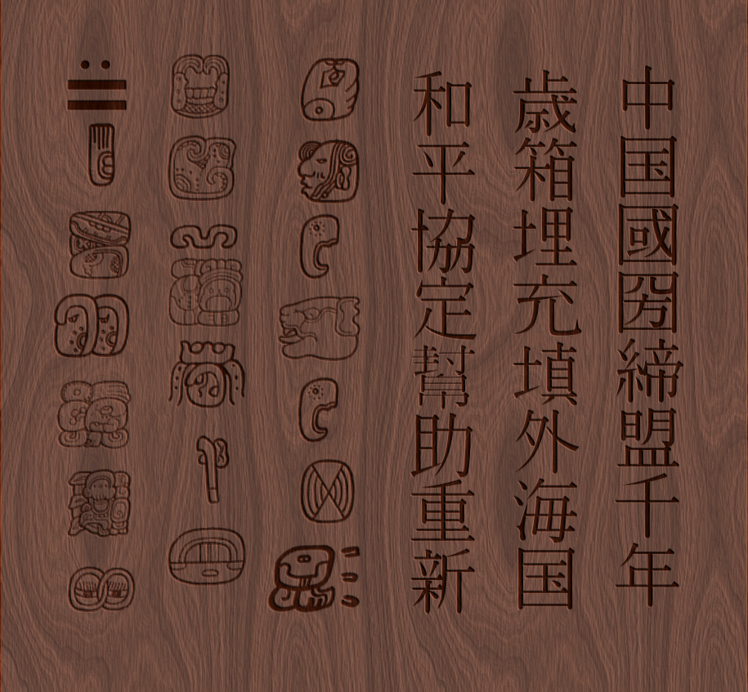
Label for Box

Atlantis Key

You can print this out and cut it out and put it on a string for Palla to wear, or use some other necklace for the key.



